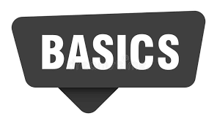

FRAMEWORK
Are pre-written code or collection of tools which make web applications fast, structured and efficient to develop and maintain

 HTML / UI Frameworks
These frameworks make page structure and layout easier to design.
- Bootstrap – Provides ready-made components like buttons, navbar, and forms; supports responsive design.
- Tailwind CSS – Uses utility-based classes to create custom designs quickly.

 CSS Frameworks
These frameworks simplify design and styling of web pages.
- Bluma – A simple, lightweight, CSS-only framework.
- Foundation – Used for advanced and responsive layouts.

⚡ JavaScript Frameworks
These frameworks help in building dynamic and interactive websites.
- React. js – Used for component-based user interface development.
- Angular – A full-featured framework for large-scale applications.
- Vue.js – Easy to learn and flexible framework.

 Back end JavaScript Frameworks
These are used for server-side development.
- Node.js + Express.js – Used for fast back-end development and REST API creation.
- Nest.js – A structured and scalable back-end framework.

FRONT-END
Frontend is the part of a website that users can see and use in the browser.
Used for:
- Page design
- Buttons, forms, images
- User interaction
Technologies:
- HTML – page structure
- CSS – design and layout
- JavaScript – interaction
Frontend Frameworks:
- React.js – builds user interface using components
- Angular – complete frontend framework
- Vue.js – simple and flexible
- Bootstrap – ready-made design components
Example:
Login page, homepage, contact form
=======================================================

Back-end
Back-end is the server-side part of a website that works behind the scenes.
Used for:
- Storing and processing data
- User authentication
- Connecting with database
Technologies:
- Node.js, Python, Java, PHP
Back-end Frameworks:
- Express.js – back-end framework for Node.js
- Django – Python back-end framework
- Spring Boot – Java back-end framework
Example:
Checking login details, saving user data, fetching data from database

DATA BASE: -
A Data Base is an organised collection of data stored on a computer, so that data can be easily stored, searched, updated, and managed.

1.Relational Database (SQL)
- Stores data in tables (rows & columns)
- Uses SQL language
Examples:
- MySQL
- PostgreSQL
- Oracle
- SQL Server
Used in: Banking systems, school records

2.Non-Relational Database (NoSQL)
- Stores data in non-table format
- Used for large and flexible data
Examples:
- MongoDB
- Cassandra
- Firebase
Used in: Big data, real-time apps

3.Object-Oriented Database
- Stores data as objects
- Used with object-oriented languages
Examples:
- Object DB
- db4o

4.Hierarchical Database
- Data stored in tree structure (parent-child)
Example:
- IBM IMS
Used in: File systems

5.Network Database
- Data stored using graph structure
- Allows many-to-many relationships
Example:
- IDMS
Used in: Airline reservation systems
FULL STACK = FRONT – END + BACK-END+ DATA-BASE

HTTP AND INTERNET BASICS

Internet
Internet is a global network that connects millions of computers.

Client-Server Architecture
Client → Sends request
Server → Sends response
Example:
Browser requests webpage → Server sends webpage

HTTP (Hyper Text Transfer Protocol)
HTTP is used for communication between client and server.

HTTP Methods:
- GET – Retrieve data
- POST – Send data
- PUT – Update data
- DELETE – Remove data

HTTP Status Codes:
- 200 – Success
- 404 – Page Not Found

API AND REST
API (Application Programming Interface)
API allows frontend and back-end to communicate.

REST API
REST is a standard way to create APIs using HTTP methods.

CRUD Operations:
- Create – POST
- Read – GET
- Update – PUT
- Delete – DELETE

J SON
JSON is a data format used to send data between client and server.
Example:
{
"name": "Rahul",
"age": 20
}

AUTHENTICATION AND AUTHORISATION

Authentication
Verifying user identity.
Example:
Login using email and password.

Authorization
Checking user permissions.
Example:
Only admin can access admin panel.

Password Hashing
Passwords should not be stored in plain text.

GIT AND GITHUB

Git
Git is a version control system used to track code changes.

GitHub
GitHub is a cloud platform to store and manage code.

Basic Commands:
- git init
- git add.
- git commit -m "message"
- git push

MVC ARCHITECTURE
MVC stands for:
- Model – Manages data
- View – User interface
- Controller – Handles request and connects Model and View
Flow:
User Request → Controller → Model → View → Response

DEPLOYMENT AND HOSTING
Hosting
Making a website available on the internet.

Deployment Platforms:
- Netlify
- Vercel
- Render

Domain
Website address (example. com)

TESTING
Testing ensures that application works correctly.
- Unit Testing – Testing individual functions
- Integration Testing – Testing multiple components together

CLOUD COMPUTING
Cloud computing means storing and running applications on internet servers instead of local machines.
Examples:
- AWS
- Microsoft Azure
- Google Cloud


HTML
- HYPER TEXT MARKUP LANGUAGE
- NOT a programming language
- Markup Lang for creating webpages
- building block of a web page

Creating an HTML file
- Doesn't need a server
- must end with. html extension
- runs in a web browser(like>chrome, fire-fox, etc.)
- index. html is a root or home page of a website
example: > if we search of domain http://www.something.com
loads the index. html file
-so the index. html is the root file of web page
here: website is collection of webpage

HTML TAGS
> HTML tag is the basic building block of any web page
>Different tags format the way that information and text is displayed
>Element names are surrounded in angle brackets
>Some tag close themselves
Structure:-
<tag name> content </tag name>
ex:-<h1>about us</h1>
self closing tags don't contain content in it
<br>,<img>(self closing tag)

HTML PAGE STRUCTURE:-
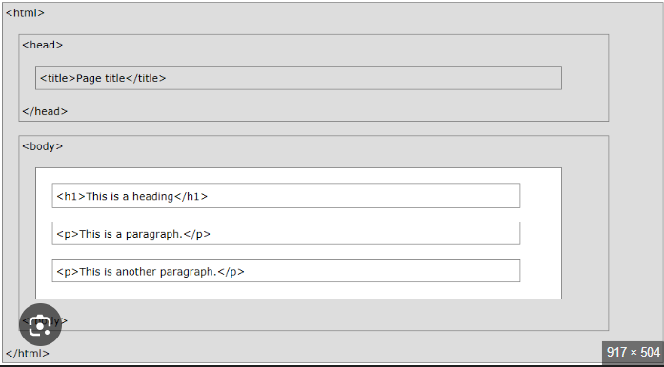

- The <html> tag is the root element that encloses the entire page content.
- The <head> section contains meta-information about the page, including the <title>.
- The <body> section contains all the visible content, such as headings (<h1>) and paragraphs (<p>).

PAGE STRUCTURE:

<!DOC TYPE html>
<html lang="en">

<head>
<meta charset="UTF-8">
<meta name="viewport" content="width=device-width, initial-scale=1.0">
<title>Title</title>
</head>
<body>
<h1>heading</h1>
<p>Paragraph</p>
</body>
</html>

Doc-type
- Explains what type of document the page is
  - HTML4, HTML5, XHTML
HTML5:-
<!DOCTYPE html>

COMMENT in HTML Document
comments in html:-
>Comments are used by developers to leave notes and explanations within the source code, making it easier to understand and maintain the code later
>They help in organising code by label different sections of an HTML page, which is crucial in large projects.
>Content within comment tags is not displayed by the web browser to the end user.
=> there are two type of comment
- single line comment
<!-- this is a comment -->
- multi-line comment
<!-- This is a multi-line comment. It can span across multiple lines to provide detailed documentation. -->

HEADING Tags in HTML Doc
There's six different tags we can use we have H1 through H6
Its define the title and subtitle of section on a web page
By default, the text size decreases from <h1> (largest) to <h6> (smallest)
Though this can be changed using CSS.
Example:-
<body>
<h1>This is a main heading</h1>
<h2>This is a section heading</h2>
<h3>This is a sub-section heading</h3>
</body>

PARA tags
- < p > tag in html
- used to define a paragraph of the text
- it structure the web-content into the readable block
- it by default auto-space before and after
- it's a fundamental block-level element,
- each <p> starts on a new line

DIFF BTW "IN-LINE" AND "BLOCK-LINE" elements
- In-line element
=>don't start in a new line
=>take only necessary width
=>height and width property has no effect
- Block-line element
=>start in new line
=>take full width
=>Can have height and width properties set with CSS.
example:-

Block-line:-
<div></div>
<h1></h1>-<h6></h6>
<form></form>
<p></p>

Inline-element:-
<span></span>
<img>
<a></a>

SEMANTIC TAG/ELEMENT
- These add meaning to the content in the web-page
- It improve SEO
- Enhance code readability
These are some semantic tag:-
- <header>: Defines the top section or introduction of a document or a section, often containing headings, logos, and navigation links.
- <nav>: Defines a section containing navigation links, such as a main menu or table of contents.
- <main>: Specifies the primary or main content of the document. There should typically be only one per page, and it should not contain content repeated across pages like sidebars or footers.
- <section>: Groups related content into a distinct section within a document, typically with a heading.
- <article>: Encapsulates self-contained, independent content that could be distributed or reused on its own, such as a blog post, a comment, or a news story.
- <aside>: Defines content tangentially related to the content around it, often presented as a sidebar or a call-out box.
- <footer>: Defines the bottom section of a document or section, typically containing copyright information, contact details, and related links.
- <figure> and <fig caption>: Used together to embed self-contained content (like an image, diagram, or code block) with a descriptive caption.
- <details> and <summary>: Creates a disclosure widget where the user can view or hide additional details. The <summary> tag provides the visible heading for the <details> block.
- <mark>: Defines text that is marked or highlighted for reference or emphasis in a particular context.
- <time>: Represents a specific date, time, or a range of time in a machine-readable format.
- <h1> to <h6>: Define the hierarchy of headings, with <h1> being the most important and <h6> the least important subheading.
- <p>: Defines a paragraph of text.
- <strong>: Indicates text of strong importance or urgency, typically displayed in bold.
- <em>: Indicates emphasised text, typically displayed in italics.

NON-SEMANTIC TAG
- General purpose container
- Don't convey the meaning about the content
Example of non -semantic tag
- <div>: A division or section, a generic container for block-level elements, used for grouping content for styling or scripting.
- <span>: An inline container used to group phrases or small parts of text for styling (e.g., changing a word's color).
- <br>: Inserts a single line break.
- <img>: Embeds an image.
- <hr>: Draws a horizontal rule.
- <script>: Embeds executable code (like JavaScript).
- <canvas>: A container for drawing graphics
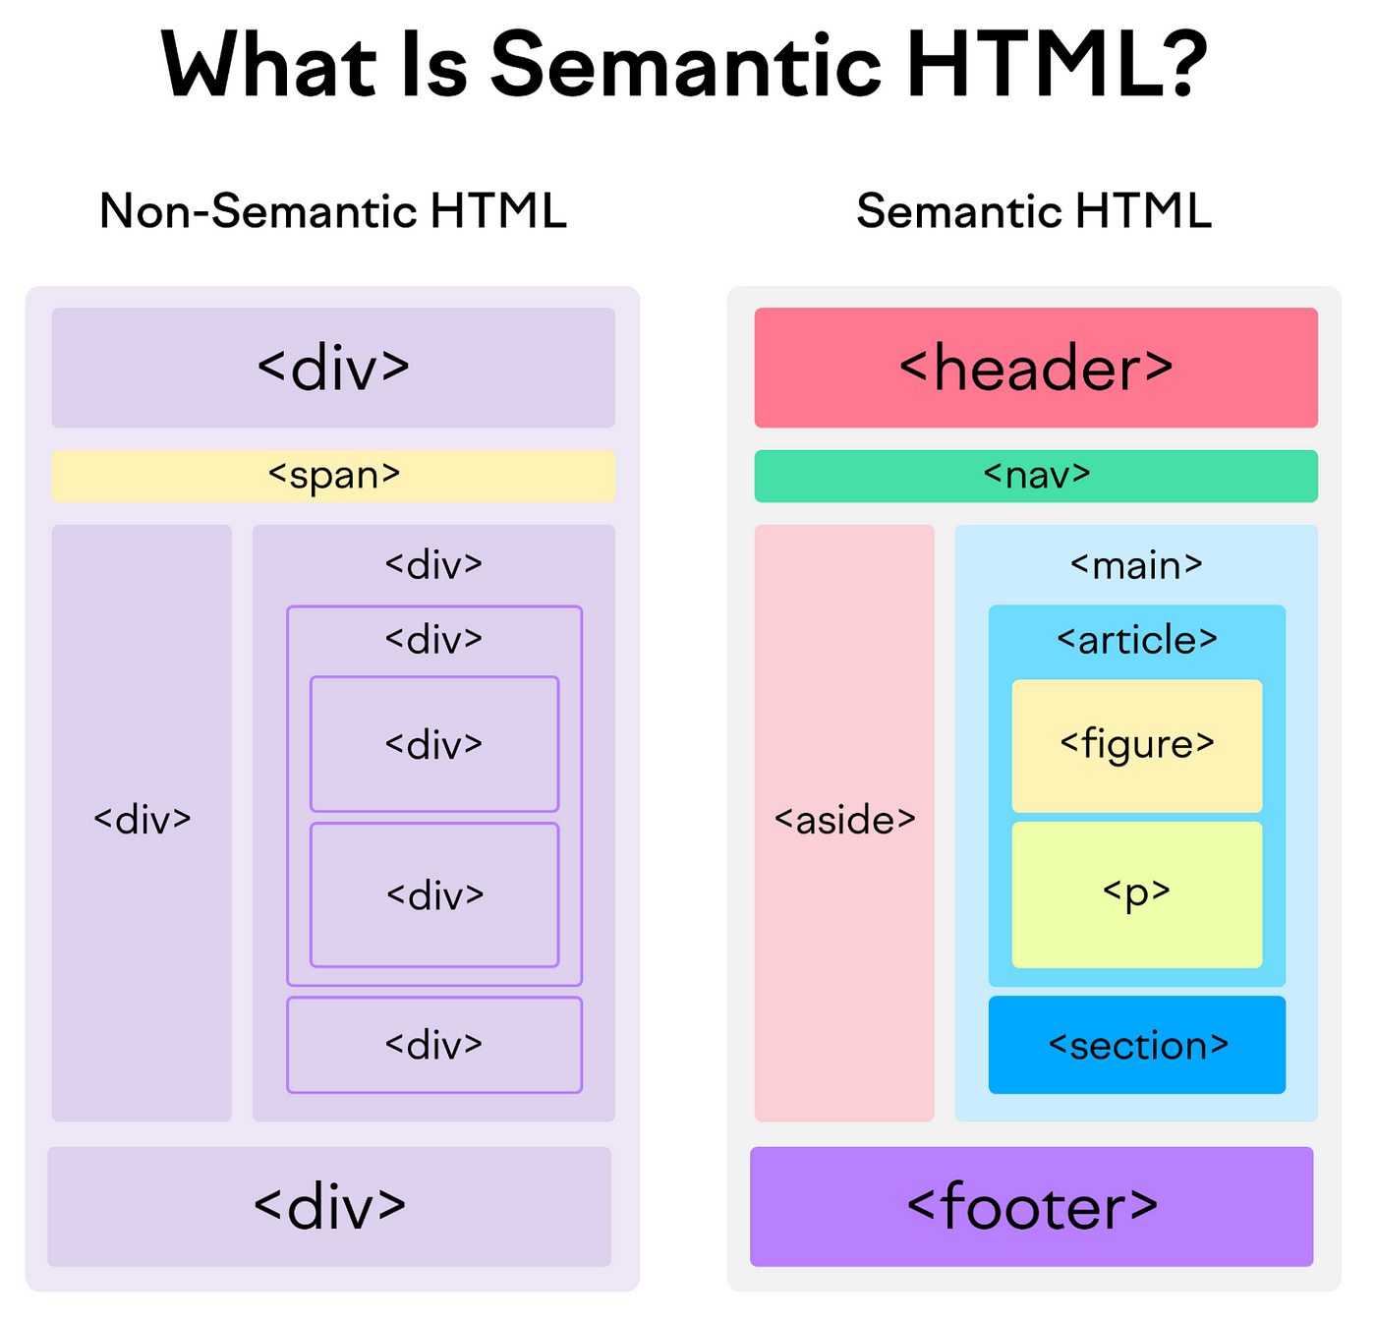

TAG ATTRIBUTES

syntax
<tag-name attribute-name="attribute-value"</tag-name>
- All tags can have attribute
- they provide information about element
- placed within start tag
- key – value pairs (id="some id")

example:-
<h1 id="about">about-us</h1> <a href="google. com" target="_ blank"> google</a>

LIST in HTML:-
- List are used to display the data / information in an organise way
- list are help to improve in readability

There are three main type of list:
- Ordered-list(<ol>)
- un-ordered- list(<ul>)
- description list(<dl>)

example:-
Un-ordered-list:-
<ul>
<li>Coffee</li>
<li>Tea</li>
<li>Milk</li>
</ul>

Ordered-list:-
<ol>
<li>Gather ingredients</li>
<li>Mix ingredients together</li>
<li>Bake in oven</li>
</ol>

Description list:-
<dl>
<dt>HTML</dt>
<dd>A markup language for creating web pages.</dd>
<dt>CSS</dt>
<dd>A style sheet language used to style HTML documents.</dd>
</dl>

TABLES in HTML
- Structured way to arrange data into row and column on a web-page
- These are primarily used for tabular data (like finance reports, schedules)
- not to use for general page layouts.

Key elements of table:-
- <table> : The main container element that defines the entire table.
- <tr> : The "table row" element, used to create a horizontal row of cells within the table.
- <th> : The "table header" element, which defines a header cell. Text in <th> cells is typically displayed as Bold and centered by default, and provides context for the column or row data.
- <td> : The "table data" element, which defines a standard data cell. This is where the actual content (text, images, links, etc.) goes.

SEMANTIC TAGS FOR TABLE
- <caption>: Defines a title or descriptive caption for the table, placed immediately after the opening <table> tag.
- <thead>: Groups the header content (usually the top row(s) with <th> elements).
- <tbody>: Groups the main body content or data rows of the table.
- <tfoot>: Groups any footer content, such as summary information or totals, and is rendered at the bottom of the table.
- <colspan> and <rowspan> attributes: Used within <th> or <td> to make a single cell span across multiple columns or rows, respectively, which is useful for complex layouts or merged headings.

example:-
<table>
<tr>
<th>Month</th>
<th>Savings</th>
</tr>
<tr>
<td>January</td>
<td>$100</td>
</tr>
<tr>
<td>February</td>
<td>$80</td>
</tr>
</table>

FORMS in Html
- The Html forms are fundamental part of web development
- These are used to collect data from user through input and send to the server for the processing

Mainly include <form> element
- This element defines the beginning and end of a form and controls how the data is submitted. Key attributes include:
- action: Specifies the URL of the server-side script that will process the form data when it is submitted.
- method: Defines the HTTP method to use for sending the data, typically GET or POST.
  - GET: Appends the form data to the URL as name/value pairs. This is suitable for non-sensitive data like search queries but has URL length limitations.
  - POST: Sends the form data in the body of the HTTP request, which is not visible in the URL. This is more secure and used for sensitive data like passwords or file uploads.

common Form Element:-
- <input>: The most versatile element, used to create a wide variety of form controls via its type attribute.
- <label>: Associates a descriptive caption with a form control. Using the for attribute (matching the input's id) enhances accessibility for screen readers and improves usability by making the label text clickable.
- <button>: Creates a clickable button. Its type attribute can be submit, reset, or button (for use with JavaScript).
- <textarea>: Defines a multi-line text input field, useful for comments or messages.
- <select>: Creates a dropdown list of options.
  - <option>: Defines an available option within a <select> list.
  - <optgroup>: Groups related options within a dropdown menu for better organization.
- <fieldset>: Groups related form controls together visually, often drawing a box around them.
- <legend>: Defines a caption or title for the content within a <fieldset>

Key input type:-
text
A single-line text input field.
password
A single-line field where characters are masked (shown as asterisks or dots) for security.
email
A field that requires a valid email address format and often triggers a relevant keyboard on mobile devices.
number
A field for entering numerical values, with optional min, max, and step attributes.
checkbox
Allows users to select zero or more options from a list.
radio
Allows users to select only one option from a set of choices that share the same name attribute.
submit
A button that submits the form data to the URL specified in the action attribute.
file
A control that lets users select a file from their local device for upload.
date, time, etc.
Specialised types for selecting dates, times, colours, etc., often providing a graphical picker.
example:-
<!DOCTYPE html>
<html>
<body>
<legend>User Information Form</legend>
<fieldset <form action="/submit_page.php" method="POST"> <label for="name">Name:</label><br> <input type="text"
id="name" name="user_name"><br> <label for="email">Email:</label><br> <input type="email" id="email"
name="user_email"><br><br> <button type="submit">Submit</button> </form>
</fieldset>
</body>
</html>

IMAGE:-
To embed an image in HTML, you use the <img> tag, which is a self-closing (empty) element. The two most important attributes are src and alt.
Ex:-
<img src="image_path.jpg" alt="Description of the image">
- src (Source): Specifies the file path or URL of the image you want to display. This can be a relative path to a file on your server (e.g., "images/dog.jpg") or an absolute URL to an external website (e.g., "https://www.example.com/images/dog.jpg").
- alt (Alternative Text): Provides a text description of the image. This is crucial for accessibility (screen readers use it) and is displayed if the image fails to load
we can customise image appearance and behaviour by some attributes
Attributes of image:-
- Width and height: Define the dimensions of the image in pixels. It is good practice to include these to prevent the page layout from shifting while the image loads.
- loading="lazy": Optimises page performance by telling the browser to only load the image when it is about to enter the user's viewport (visible area).
- title: Adds extra information that appears as a tooltip when a user hovers their mouse over the image.
- Image as a Link: To make an image clickable, nest the <img> tag inside an anchor <a> tag

Quotation in HTML
- specific elements and character entities are used to handle quotations semantically.
- This provides structure and accessibility benefits beyond simply typing quotation marks

Quotation Elements:-
- <q> (Inline Quotation)
The <q> tag is used for short quotes that appear within a flow of text. Browsers automatically add quotation marks around the content.
- <blockquote> (Block Quotation)
The <blockquote> element defines a section that is quoted from another source, typically displayed as an indented block separate from the main text.
- <cite>
This tag is used to mark up the title of a creative work (e.g., a book, song, movie, or article). Browsers usually render the content in italics by default.
- <footer>
Often used within a <blockquote> to clearly associate the author or source name (which is not part of the creative work's title) with the quote.

example:-
<p>WWF's goal is to: <q cite="https://www.worldwildlife.org/who/index.html">Build a future where people live inharmony
with nature.</q></p>
example-2:-
<blockquote>
<p>The only limit to our realization of tomorrow is our doubts of today.</p>
<footer>— <cite>Franklin D. Roosevelt</cite></footer>
</blockquote>
<p>My favourite book is <cite>Pride and Prejudice</cite> by Jane Austen.</p>

Abbreviation in Html
- Used to define abbreviation in web page
- Its primary purpose is to provide semantic meaning to the text
- The most common and recommended way to use the <abbr> tag is with the global title attribute. The value of the title attribute should be the full expansion of the abbreviation
example:-
<p>The <abbr title="World Health Organisation">WHO</abbr> was founded in 1948.</p>

META TAGS &SEO OPTIMIZATION:-
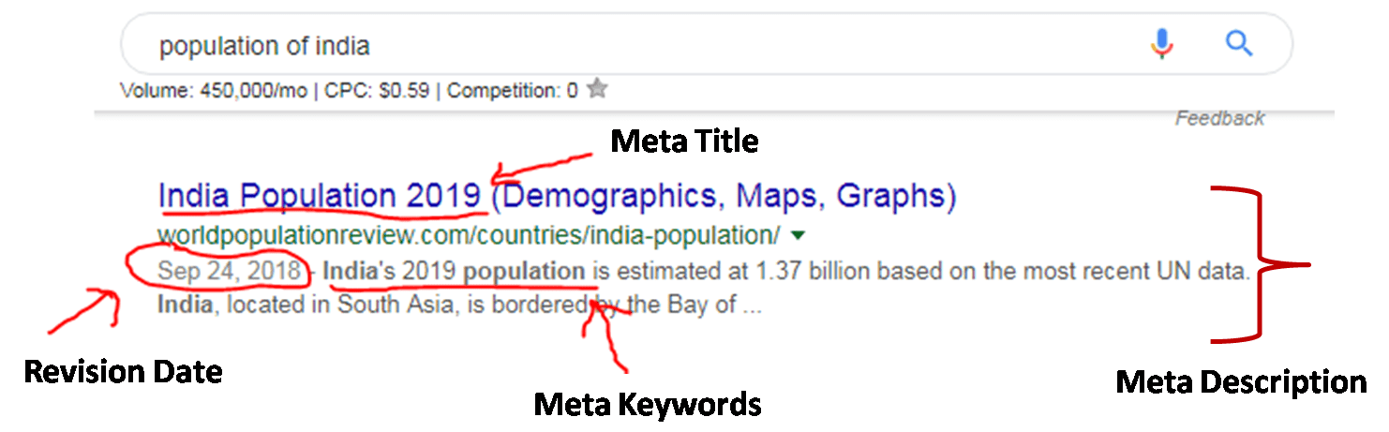
META TAGS & SEO

Meta Tags provide information about an HTML document.
They are written inside the <head> section and are mainly used for Search Engine Optimization (SEO).

Features of Meta Tags:
- Provide metadata about the webpage
- Help search engines understand page content
- Improve website ranking (SEO)
- Not visible to users
Common meta Tags
<meta name="description" content="Web Development">
<meta name="keywords" content="HTML, CSS, JavaScript">
<meta name="author" content="Author Name">
<meta name="viewport" content="width=device-width, initial-scale=1.0">

HTML Hyper-link:-
The <a> (anchor) tag is used to create hyperlinks in a webpage.
Hyperlinks are used to connect one webpage to another.

Attributes used
• href → specifies the URL
• target="_blank" → opens link in new tab

Types of Links:
- Internal link
- External link
Example:-
<a href="https://www.google.com" target="_blank">Google</a>

HTML5-MULTIMEDIA
HTML5 provides built-in support for multimedia without using plugins.

Audio Tag
<audio controls>
<source src="audio.mp3" type="audio/mpeg">
</audio>

Video Tag
<video controls width="300">
<source src="video.mp4" type="video/mp4">
</video>

Common Attributes:
- controls
- autoplay
- loop

I FRAMES:-
Its used to embed another HTML document in the other web-page
Syntax:-
<i frame src="url_of_page" >
</i frame>
Attribute:-
- src: Specifies the URL of the page to embed.
- width and height: Define the dimensions of the iframe in pixels (by default) or percentages.
- loading="lazy": Tells the browser to defer loading the iframe until the user scrolls near it, improving page performance.

Example
<iframe src="Http://google. com" width="600" height="400">
</iframe>



CSS
- cascading style sheet
- not a programming language
- style-sheet/styling language
- used for website layout and design
- no need of programming logic

Method to add CSS
- Inline CSS:
Directly in the html (element no!)
- Internal CSS:
Using <Style> tag within single document
- External CSS:
linking an external. CSS file
Inline | Internal | External
Within the HTML element using the style attribute. | In the <head> section of the HTML document within <style> tags. | In a separate file with a .css extension, linked via a <link> tag in the <head>
cannot be reused | only reusable on the same page | reusable across the entire website
Very difficult to manage for multiple elements. | Manageable for single pages, difficult for multi-page sites | High (centralized changes update the whole site).
Not recomended | mostly recomended | Highly recomended

CSS Selectors:-
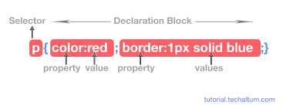

COLORS in CSS
- Colour name
- HTML5 colour names
- Hexa decimal (Hex code)
- RGB
- R-G-B-A

example:-
body{
color: red;
background: coral;
}
h1{
color: #00ff00;
}
p{
color: rgb(25,1,255);
background-color: rgba(204, 204, 251, 0);
}

Fonts:
Fonts in CSS are controlled using a set of properties, with the most common being font-family, font-size, and font-weight. These properties can be applied individually or using the shorthand font property

Font properties:-
font-family: Specifies the font to be used for text. You should list multiple fonts as a "fallback" system, separated by commas, ending with a generic family name (e.g., serif, sans-serif, monospace) in case the preferred fonts are unavailable on the user's system.
font-size: Controls the size of the text. Common units include pixels (px), ems (em), and rems (rem) for responsive design. default(16px)
font-weight: Sets the thickness of the characters. Values can be keywords like normal or bold, or numeric values between 100 and 900.
font-style: Specifies the style of the font, most commonly normal, italic, or oblique.
color: Sets the color of the text.
We can also use External font like Google fonts
line-height
- CSS property controls the vertical spacing between lines of text within an element.
- It is essential for readability and visual design and is most often defined using a unitless number to ensure responsiveness and proper inheritance

Selectors, Classes, IDs, and Container
- Selector targets elements (e.g., body {}); class (.class) reusable, ID (#id) unique.
- Container class: width: 80%; margin: auto; centres content responsively (use % over px).
- Example: .box1 { background-color: #333; color: #fff; }.

Feature | Class Selector | ID Selector
Usage | Can be applied to multiple elements on a single page. | Must be unique to one element per HTML document.
Syntax (CSS) | Uses a period (.) followed by the class name (e.g., .button). | Uses a hash (#) followed by the ID name (e.g., #primary-nav).
HTML Attribute | Assigned using the class attribute (e.g., <div class="example">). | Assigned using the id attribute (e.g., <div id="example">).
Specificity | Has lower specificity than an ID. | Has higher specificity than a class, which means its styles will override conflicting class styles.

BOX MODEL:-
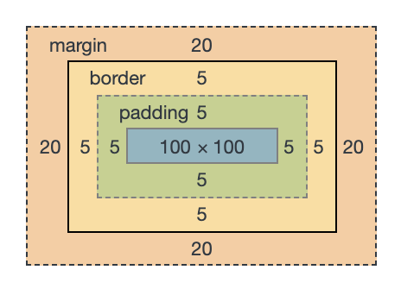

Shorthand syntax for margin and padding
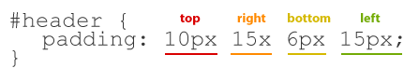

Box Styling
- Content: The actual text, image, or other media within the box. Its size is controlled by width and height properties.
- Padding: The space inside the border, around the content. It is transparent and controlled by the padding properties.
- Border: A line that goes around the padding and content. Its appearance is defined by border-width, border-style, and border-color properties.
- Margin: The space outside the border, used to create distance between the current box and other elements. It is also transparent and controlled by the margin properties.

Margin vs padding:-
- Margin and padding both create space in web design
- margin is outside an element's border
>For spacing between Elements
- padding is inside of an element border
>for spacing between content and border

PROPERTY | DESCRIPTION | SYNTAX
width, height | Sets the dimensions of the content area. | Width : 200px;
Padding | Shorthand for all four sides of inner space | padding: 10px 20px;
Border | Shorthand for width, style, and color of the border | border: 2px solid red;
Margin | Shorthand for all four sides of outer space. | ```margin: 15px auto`
background-color | Sets the color of the content and padding areas | background-color: #f0f0f0;
box-sizing | Changes how width and height are calculated. | Box-sizing: border-box;
border-radius | Adds rounded corners to the box and border. | Border-radius: 8px;
box-shadow | Adds shadow effects around an element’s frame. | Box-shadow: 2px 5px rgba(0,0,0,0.3);

Text layout Properties
These properties affect the spacing, alignment, decoration, and positioning of the text block.
- text-align: Sets the horizontal alignment of the text within its container to left, right, centre, or justify.
- text-decoration: A shorthand property to add or remove decorations like underline, overline, line-through, along with their style, color, and thickness. This is commonly used to remove the default underline from links (text-decoration: none.
- text-transform: Controls the capitalisation of text using values like uppercase, lowercase, capitalise, or none.
- text-indent: Specifies the indentation of the first line of text in a block.
- line-height: Sets the distance (leading) between lines of text to improve readability.
- letter-spacing: Specifies the extra space between individual characters.
- word-spacing: Specifies the space between words in a block of text.
- white-space: Controls how white space inside an element is handled (e.g., preventing line breaks or preserving spaces).
- vertical-align: Sets the vertical alignment of an element (used with inline or table-cell elements)

List styling:-
These are some properties that are typically applied to the parent element (<ul> or <ol>)
list-style-type: Defines the appearance of the list marker (bullet or number).
- Unordered list values: disc (default), circle, square, none.
- Ordered list values: decimal (default), decimal-leading-zero, lower-roman, upper-roman, lower-alpha, upper-alpha
- can also use an emoji or custom string as the marker with this property in modern CSS, applied to both (<ul>and <ol>)e.g., list-style-type: ‘❤️’
list-style-image: Allows you to use a custom image
- Example: list-style-image: url(‘my-bullet.png’);.
List-style-position: Specifies whether the marker box is inside or outside the main content flow of the list item.
- outside (default): The marker is outside the line of text, and subsequent lines align vertically with the start of the first line’s text.
- inside: The marker is part of the list item’s content flow, so subsequent lines of text will wrap underneath the marker itself.

Form styling:
Styling forms with CSS involves using various properties like width, padding, margin, border-radius, and pseudo-classes such as :hover and :focus to enhance visual appeal and user experience.

Key CSS Properties for Form Elements
You can style various form elements, including input (text, password, checkbox, radio, submit), textarea, select, and button.
- width and height: Control the dimensions of form fields. Using percentages (e.g., width: 100%;) can help with responsive design.
- padding and margin: Add space inside (padding) and outside (margin) elements for better readability and layout.
- border and border-radius: Customise borders and add rounded corners for a modern look.
- background-color and color: Change the background and text colors to match your website’s design.
- font properties: Ensure consistency by setting font-family, font-size, and font-weight for all form elements, as they might not inherit from the body by default.
- box-sizing: border-box;: This crucial property ensures that padding and borders are included in the element’s total width and height, preventing layout issues.
- cursor: pointer;: Change the cursor to a hand icon for buttons and interactive elements to provide visual feedback.

Using Selectors
Target specific elements using various CSS selectors:
- Type selectors: input, textarea, button
- Attribute selectors: input[type=”text”], input[type=”submit”]
- Class/ID selectors: .form-control, #submit-button
- Pseudo-classes:
  - :focus: Styles the input field when a user clicks on or tabs to it, often used to change the border or background color to indicate it’s active.
  - :hover: Styles elements, especially buttons, when the user’s mouse cursor is over them.
  - :checked: Styles checkboxes or radio buttons when they are selected.
  - :disabled: Styles form elements that are not interactive, typically making them look grayed out.
- Pseudo-elements: ::placeholder targets the placeholder text within an input field

example:-
A form with CSS styling:-
<!DOCTYPE html>
<html lang=”en”>
<head> <meta charset=”UTF-8”> <meta name=”viewport” content=”width=device-width, initial-scale=1.0”> <title>Document</title> <style>
input[type=”text”],
select,
textarea {
width: 100%;
padding: 12px;
border: 1px solid #ccc;
border-radius: 4px;
box-sizing: border-box;
margin-top: 6px;
margin-bottom: 16px;
resize: vertical;
}
input[type=”submit”] {
background-color: #54bd75;
color: white;
padding: 12px 20px;
border: none;
border-radius: 4px;
cursor: pointer;
}
input[type=”submit”]:hover {
background-color: #72aa72;
}
</style>
</head>
<body> <div class=”form-container”> <form action=”/submit-page” method=”POST”> <label for=”fname”>First Name</label> <input type=”text” id=”fname” name=”firstname” placeholder=”Your name…”>
<label for=”lname”>Last Name</label>
<input type=”text” id=”lname” name=”lastname” placeholder=”Your last name…”>

<label for=”country”>Country</label>
<select id=”country” name=”country”>
<option value=”USA”>USA</option>
<option value=”18ransl”>Canada</option>
<option value=”18ranslate”>Australia</option>
</select>

<label for=”subject”>Subject</label>
<textarea id=”subject” name=”subject” placeholder=”Write something…”></textarea>

<input type=”submit” value=”Submit”>
</form>
</div>
</body>
</html>

FLOAT Property in CSS:-
Syntax:-
selector {
float: value;
};
- The CSS float property positions an element to the left or right of its container, allowing text and other inline elements to wrap around it.
- The floated element is removed from the normal document flow, which is how the wrapping effect is achieved.

The float property accepts the following values:-
- Inherit, inline-end, inline-start, right, left, none

CSS Positioning
CSS positioning controls where and how elements are placed on a web page, sometimes overriding the normal document flow.
The position property is used along with top, bottom, left, and right to define an element’s final position.
Types of CSS Position Property
- static
  - Default position of all elements
  - Follows normal document flow
  - top, left, right, bottom have no effect
- relative
  - Positioned relative to its original position
  - Offset properties move the element
  - Space of the element is still preserved
- absolute
  - Removed from normal document flow
  - Positioned relative to the nearest positioned ancestor
  - If no ancestor exists, positioned relative to the viewport
- fixed
  - Removed from normal document flow
  - Positioned relative to the browser window
  - Remains fixed even when the page is scrolled
- sticky
  - Acts as relative initially
  - Becomes fixed after reaching a scroll position (e.g., top: 0)
  - Stops sticking when its container ends

PSEUDO – CLASS in CSS
Syntax:
selector: pseudo-class

- CSS pseudo-classes are keywords added to selectors to style an element based on a specific state, user interaction, or document structure
- They allow developers to create interactive and dynamic designs without needing additional JavaScript or manual HTML class changes.
Categories of pseudo class are:-
- User Action (Interaction): Targets real-time behaviour.
  - :hover – Styles an element when the mouse pointer is over it.
  - :focus – Applies when an element, like a text input, is selected or tabbed to.
  - :active – Styles an element while it is being actively clicked.
- Structural (Tree-Structural): Targets elements based on their position in the document.
  - :first-child / :last-child – Selects the first or last child element of its parent.
  - :nth-child(n) – Targets an element based on its specific numerical index among siblings.
- Link Status (Location): Specific to anchor (<a>) tags.
- :link – Styles unvisited links.
- :visited – Styles links the user has already visited.
Structural Pseudo-Classes
These target elements based on their position within the document structure.
- :first-child: Selects the first element among a group of siblings.
- :last-child: Selects the last element among a group of siblings.
- :nth-child(n): Selects elements based on their position (e.g., odd, even)
- :only-child: Selects an element that is the only child of its parent.
- :root: Selects the document’s root element (usually the <html> element)
Form and UI States
These are useful for styling form elements dynamically based on their state.
- :checked: Matches checkboxes or radio buttons that are selected (toggled on).
- :disabled: Selects elements that are disabled and cannot be interacted with.
- :enabled: Selects elements that are enabled (the default state).
- :required: Selects input elements that have the required attribute set.
- :invalid: Selects form elements with content that does not meet the specified validation constraints (e.g., an invalid email format in an input type=”email”).

Example:-
/* Styles for links on hover */
a: hover {
color: red;
text-decoration: underline;
}

/* Styles for the first paragraph in an article */
article p: first-child {
font-weight: bold;
}

/* Styles for a text input when it is focused */
input: focus {
border: 2px solid blue;
}

Media – query in CSS:-
Media queries in CSS are a key component of responsive web design
It allows us to conditionally apply styles based on the characteristics of the user’s device or the browsing environment
Syntax:-
@media
Example:-
@media screen and (max-width: 600px) {
body {
background-color: lightblue;
}
}

Common media features:-
- width / min-width / max-width: The most common features, used to apply styles based on the width of the viewport.
- height / min-height / max-height: Based on the height of the viewport.
- orientation: Checks if the device is in portrait (height >= width) or landscape (width > height) mode.
- prefers-color-scheme: Detects if the user prefers a light or dark color scheme in their system settings.
- prefers-reduced-motion: Detects if the user has requested minimal animations or motion due to motion sensitivity.
- hover / pointer: Detects the presence and accuracy of a pointing device (e.g., mouse vs. touchscreen).

CSS Grid:
text
.container {
display: grid;
grid-template-columns: auto;
grid-gap: 10px;
}

Flex box:
text
.container {
display: flex;
justify-content: centre;
align-items: centre;
}

Animations:
text
@keyframes example {
from {background-color: red;}
to {background-color: yellow;}
}

.element {
animation: example 2s;
}

FLEX-BOX IN CSS
Flexbox (Flexible Box Layout):
- CSS layout module for one-dimensional layout (row OR column)
- Makes it easier to design flexible responsive layout
- Container becomes flex container, children become flex items

Main Properties:
Container Properties:
- display: flex; - Activates flexbox
- flex-direction: - Defines main axis
  - row (default), row-reverse, column, column-reverse
- justify-content: - Aligns items along main axis
  - flex-start, flex-end, centre, space-between, space-around, space-evenly
- align-items: - Aligns items along cross axis
  - stretch (default), flex-start, flex-end, centre, baseline
- flex-wrap: - Controls wrapping
  - nowrap (default), wrap, wrap-reverse
- align-content: - Aligns lines in multi-line flex container
  - Only works when flex-wrap: wrap

Item Properties:
- order: - Controls visual order (default: 0)
- flex-grow: - Ability to grow (default: 0)
- flex-shrink: - Ability to shrink (default: 1)
- flex-basis: - Initial size before remaining space distributed
- align-self: - Overrides align-items for individual item
Example:
CSS
.container {
display: flex;
flex-direction: row;
justify-content: centre
align-items: centre;
flex-wrap: wrap;
}

.item {
flex: 1; /* shorthand for flex-grow: 1, flex-shrink: 1, flex-basis: 0 */
}
- CSS GRID SYSTEM
- CSS Grid:
- Two-dimensional layout system (rows AND columns simultaneously)
- More powerful than Flexbox for complex layouts
- Creates grid container with rows and columns

Grid Properties:

Container Properties:
- display: grid; or display: inline-grid;
- grid-template-columns: - Defines column sizes
  - e.g., grid-template-columns: 100px auto 100px;
- grid-template-rows: - Defines row sizes
- grid-template-areas: - Names grid areas
- grid-gap / gap: - Space between rows and columns
  - grid-row-gap, grid-column-gap (older)
  - gap: 20px; (new shorthand)
- justify-items: - Aligns grid items along row axis
- align-items: - Aligns grid items along column axis
- grid-auto-flow: - Controls auto-placement
  - row (default), column, dense

Item Properties:
- grid-column: - Start/end positions
  - grid-column: 1 / 3; (span 2 columns)
- grid-row: - Start/end positions
- grid-area: - Names item or positions
- justify-self: - Overrides justify-items
- align-self: - Overrides align-items

Example:
CSS
.container {
display: grid;
grid-template-columns: repeat(3, 1fr);
grid-gap: 10px;
}

.item {
grid-column: 1 / span 2;
grid-row: 1;
}

CSS ANIMATIONS & TRANSITIONS

CSS Transitions:
- Smoothly changes property values over given duration
- Shorthand: transition: property duration timing-function delay;
Transition Properties:
- transition-property: - Which properties to animate
- transition-duration: - How long transition takes
- transition-timing-function: - Speed curve
  - ease (default), linear, ease-in, ease-out, ease-in-out
- transition-delay: - When transition starts
Example:
CSS
.box {
width: 100px;
transition: width 2s ease-in-out 0.5s;
}

.box: hover {
width: 200px;
}

CSS Animations:
- More control than transitions
- Uses @keyframes rule
- Can change multiple properties multiple times

Animation Properties:
- animation-name: - Name of @keyframes rule
- animation-duration: - How long animation lasts
- animation-timing-function: - Speed curve
- animation-delay: - Start delay
- animation-iteration-count: - infinite or number
- animation-direction: - normal, reverse, alternate, alternate-reverse
- animation-fill-mode: - Styles before/after animation
- animation-play-state: - running or paused
Example:
CSS
@keyframes slidein {
from { transform: tr23ranslate%); }
to { transform: tr23ranslate00%); }
}

.element {
animation: slidein 3s ease-in-out infinite;
}

CSS TRANSFORMS

Transform Property:
- Modifies element's’coordinate space
- Can rotate, scale, skew, or translate element

Transform Functions:
- translate() - –oves element
  - tr23ranslate, tr23ranslate, tr23ranslate
- rotate() - –otates element
  - ro23ransl, ro23ransl, ro23ransl
- scale() - –esizes element
  - scaleX(), scaleY()
- skew() - –kews element
  - skewX(), skewY()
- matrix() - –D transformation matrix

Example:
CSS
.element {
transform: rotate(45deg) scale(1.5) tr24ranslate0px);
}

RESPONSIVE DESIGN

Viewport Meta Tag:
html
<meta name="viewport content”="width=device-width, initial-scale=1.0">”Responsive Units:
- % - Percentage of parent element
- vw/vh - –viewport width/height (1vw = 1% of viewport width)
- em - –relative to font-size of element
- rem - –relative to font-size of root element (html)
- px - –fixed pixels

Media Query Syntax:
CSS
/* Mobile First Approach */
@media (min-width: 768px) { /* Tablet */ }
@media (min-width: 992px) { /* Desktop */ }
@media (min-width: 1200px) { /* Large Desktop */ }

/* Breakpoints */
/* Extra small: <576px */
/* Small: ≥576px */
/* Medium: ≥768px */
/* Large: ≥992px */
/* Extra-large: ≥1200px */

CSS SPECIFICITY & CASCADE

Specificity Hierarchy (High to Low):
- Inline styles (style attribute) - –000 points
- ID selectors (#id) - –00 points
- Class/Attribute/Pseudo-class selectors - –0 points
- Element/Pseudo-element selectors - – point

!important Rule:
- Overrides all other declarations
- Use sparingly (bad practice to overuse)
- Example: color: red !important;

Inheritance:
- Some properties inherit from parent to child
- Text-related properties usually inherit (color, font-family, etc.)
- Box-model properties usually don’t ‘inherit (margin, padding, border)

CSS UNITS COMPARISON
Unit | Description | Relative To
Px | Pixels | Absolute unit
% | Percentage | Parent element
Em | Relative unit | Font-size of element
Rem | Root em | Font-size of root element
Vw | Viewport width | 1% of viewport width
Vh | Viewport height | 1% of viewport height
Vmin | Viewport minimum | 1% of viewport’s ’smaller dimension
Vmax | Viewport maximum | 1% of viewport’s ’larger dimension



JAVASCRIPT

JAVASCRIPT BASICS

What is JavaScript?
- High-level, interpreted programming language
- Adds interactivity to web pages
- Client-side scripting language
- ECMA Script specification

Variables:
var name = "John"; // Old, function-scoped
let age = 25; // New, block-scoped
const PI = 3.14; // Constant, cannot be reassigned

Data Types:
- Primitive: String, Number, Boolean, Undefined, Null, Symbol, BigInt
- Non-primitive: Object, Array, Function

Operators:
- Arithmetic: +, -, *, /, %, ++, --
- Comparison: ==, ===,!=,!==, >, <, >=, <=
- Logical: &&, ||,!
- Assignment: =, +=, -=, *=, /=

Difference: == vs ===
- == (Loose equality): Compares values after type conversion
- === (Strict equality): Compares values AND types
Example:
Java-script
5 == "5" // true (type conversion)
5 === "5" // false (different types)

FUNCTIONS
Function Declaration:
Java-script
function greet(name) {
return "Hello " + name;
}
Function Expression:
Java-script
Const greet = function(name) {
return "Hello " + name;
};
Arrow Function (ES6):
JavaScript
const greet = (name) => {
return "Hello " + name;
};

// Shorter
const greet = name => "Hello " + name;
Function Parameters:
Java script
// Default parameters
function greet(name = "Guest") {
return "Hello " + name;
}

// Rest parameters
function sum(...numbers) {
return numbers. Reduce((a, b) => a + b);
}

DOM MANIPULATION
What is DOM?
- Document Object Model
- Tree structure of HTML document
- JavaScript can manipulate DOM dynamically
Selecting Elements:
Java-script
// Single element
document.getElementById("id");
document.querySelector(".class");

// Multiple elements
document.getElementsByClassName("class");
document.getElementsByTagName("div");
document.querySelectorAll(".class");
DOM Manipulation Methods:
Java script
// Changing content
element.innerHtml = "<h1>New Content</h1>";
element.textContent = "Plain text";

// Changing attributes
element.setAttribute("class", "new-class");
element.getAttribute("src");
element.removeAttribute("disabled");

// Changing style
element.style.color = "red";
element.style.backgroundColor = "blue";

// Adding/removing classes
element.classList.add("new-class");
element.classList.remove("old-class");
element.classList.toggle("active");
Creating/Removing Elements:
javascript
// Create element
const newDiv = document.createElement("div");

// Add to DOM
parentElement.appendChild(newDiv);
parentElement.insertBefore(new Div, reference Element);

// Remove element
element. Remove();
parentElement.removeChild(childElement);

EVENTS

Event Handling:
javascript
// Method 1: HTML attribute
<button onclick="handleClick()">Click</button>

// Method 2: DOM property
element.onclick = function() { console.log("Clicked"); };

// Method 3: addEventListener (Recommended)
element.addEventListener("click", function() {
console.log("Clicked");
});

// With event object
element.addEventListener("click", function(event) {
console.log(event.target); // Element that triggered event
event.preventDefault(); // Prevent default behavior
});

Common Events:
- Mouse: click, dblclick, mouseover, mouseout, mousedown, mouseup
- Keyboard: keydown, keyup, keypress
- Form: submit, change, focus, blur, input
- Window/Document: load, resize, scroll

Event Propagation:
- Capturing Phase (top to target)
- Target Phase
- Bubbling Phase (target to top)

Stop Propagation:
javascript
event.stopPropagation(); // Stop bubbling
event.stopImmediatePropagation(); // Stop all handlers

FORM VALIDATION

Basic Validation:
javascript
function validateForm() {
const name = document.getElementById("name").value;

if (name === "") {
alert("Name must be filled out");
return false;
}

return true;
}

Email Validation:
javascript
function validateEmail(email) {
const regex = /^[^\s@]+@[^\s@]+\.[^\s@]+$/;
return regex.test(email);
}

Password Validation:
javascript
function validatePassword(password) {
// At least 8 characters, 1 uppercase, 1 lowercase, 1 number
const regex = /^(?=.*[a-z])(?=.*[A-Z])(?=.*\d)[a-zA-Z\d]{8,}$/;
return regex.test(password);
}

ASYNCHRONOUS JAVASCRIPT
Asynchronous JavaScript allows code to execute without blocking the main program.
It helps keep the webpage responsive.
Examples:
- Set Timeout()
- Set Interval()
example:-
set Timeout(() => {
console.log("Hello");
}, 2000);

FETCH API
Fetch API is a modern JavaScript method used to request data from a server.
It is asynchronous and returns a Promise.
Syntax:
fetch("u r l")
.then(response => response . json ())
.then(data => console.log(data));

Features of Fetch API:
- Used for HTTP requests
- Works asynchronously
- Handles JSON data
- Simplifies server communication

JSON (JavaScript Object Notation)
JSON is a lightweight data format used to exchange data between client and server.

Features of JSON:
- Text-based format
- Uses key-value pairs
- Easy to read and write
Example:
{
"name": "Amit",
"age": 21
}



BOOTSTRAP

BOOTSTRAP BASICS
What is Bootstrap?
- Most popular CSS framework
- Open-source toolkit for developing responsive websites
- Mobile-first approach
- Pre-built components and utilities

Bootstrap Setup:
HTML
<!-- CSS -->
<link href="https://cdn.jsdelivr.net/npm/bootstrap@5.3.0/dist/css/bootstrap.min.css" rel="stylesheet">

<!-- JS Bundle -->
<script src="https://cdn.jsdelivr.net/npm/bootstrap@5.3.0/dist/js/bootstrap.bundle.min.js"></script>

GRID SYSTEM
Bootstrap Grid:
- 12-column grid system
- Responsive breakpoints
- Container → Row → Column structure
Breakpoints:
- xs: <576px (Extra small)
- sm: ≥576px (Small)
- md: ≥768px (Medium)
- lg: ≥992px (Large)
- xl: ≥1200px (Extra large)
- xxl: ≥1400px (Extra extra large)

Grid Classes:
html
<div class="container">
<div class="row">
<div class="col-sm-6 col-md-4 col-lg-3">
<!-- Content -->
</div>
<div class="col-sm-6 col-md-8 col-lg-9">
<!-- Content -->
</div>
</div>
</div>

Auto-layout Columns:
html
<div class="row">
<div class="col">Equal width</div>
<div class="col">Equal width</div>
<div class="col">Equal width</div>
</div>

BOOTSTRAP COMPONENTS
Buttons:
html
<button class="btn btn-primary">Primary</button>
<button class="btn btn-secondary">Secondary</button>
<button class="btn btn-success">Success</button>
<button class="btn btn-danger">Danger</button>
<button class="btn btn-warning">Warning</button>
<button class="btn btn-info">Info</button>
<button class="btn btn-light">Light</button>
<button class="btn btn-dark">Dark</button>
<button class="btn btn-link">Link</button>

Navigation Bar:
html
<nav class="navbar navbar-expand-lg navbar-light bg-light">
<div class="container-fluid">
<a class="navbar-brand" href="#">Navbar</a>
<button class="navbar-toggler" type="button" data-bs-toggle="collapse" data-bs-target="#navbarNav">
<span class="navbar-toggler-icon"></span>
</button>
<div class="collapse navbar-collapse" id="navbarNav">
<ul class="navbar-nav">
<li class="nav-item">
<a class="nav-link active" href="#">Home</a>
</li>
<li class="nav-item">
<a class="nav-link" href="#">Features</a>
</li>
</ul>
</div>
</div>
</nav>

Cards:
html
<div class="card" style="width: 18rem;">
<img src="..." class="card-img-top" alt="...">
<div class="card-body">
<h5 class="card-title">Card title</h5>
<p class="card-text">Some quick example text.</p>
<a href="#" class="btn btn-primary">Go somewhere</a>
</div>
</div>

Forms:
html
<form>
<div class="mb-3">
<label for="exampleInputEmail1" class="form-label">Email address</label>
<input type="email" class="form-control" id="exampleInputEmail1">
<div id="emailHelp" class="form-text">We'll never share your email.</div>
</div>
<div class="mb-3">
<label for="exampleInputPassword1" class="form-label">Password</label>
<input type="password" class="form-control" id="exampleInputPassword1">
</div>
<button type="submit" class="btn btn-primary">Submit</button>
</form>

BOOTSTRAP CAROUSEL (Dynamic Component)
Carousel is a Bootstrap component used to display images or content in a slideshow format.

Features:
- Automatically cycles content
- Used for banners and image sliders
- Responsive and interactive

BOOTSTRAP UTILITIES
Spacing:
- m - margin, p - padding
- t - top, b - bottom, s - start(left), e - end(right), x - horizontal, y - vertical
- 0-5 - size (0:0, 1:0.25rem, 2:0.5rem, 3:1rem, 4:1.5rem, 5:3rem)
- auto - auto margin

Examples:
html
<div class="mt-3">Margin top 1rem</div>
<div class="p-4">Padding all sides 1.5rem</div>
<div class="mx-auto">Center horizontally</div>
Display:
html
<div class="d-none">Hidden</div>
<div class="d-block">Block</div>
<div class="d-inline">Inline</div>
<div class="d-flex">Flex</div>
<div class="d-grid">Grid</div>

<!-- Responsive -->
<div class="d-none d-md-block">Hidden on mobile, block on medium+</div>
Flex Utilities:
html
<div class="d-flex justify-content-between">
<div>Item 1</div>
<div>Item 2</div>
</div>

<div class="d-flex align-items-center">
<div>Centered vertically</div>
</div>

IMPORTANT DIFFERENCES
HTML vs HTML5
HTML | HTML5
No semantic elements | Semantic elements (header, footer, article, section)
Required plugins for multimedia | Built-in audio/video support
Limited form input types | New input types (email, date, color, range)
No canvas element | Canvas for graphics
No local storage | LocalStorage and SessionStorage
Doctype declaration complex | Simple <!DOCTYPE html>

CSS Flexbox vs Grid
Flexbox | Grid
One-dimensional layout | Two-dimensional layout
Row OR column | Row AND column simultaneously
Content-based | Container-based
Better for components | Better for page layouts
Browser support: Good | Browser support: Good

var vs let vs const
var | let | const
Function-scoped | Block-scoped | Block-scoped
Can be redeclared | Cannot be redeclared | Cannot be redeclared
Can be updated | Can be updated | Cannot be updated
Hoisted with undefined | Hoisted but not initialized | Hoisted but not initialized

GET vs POST

GET | POST
Data in URL | Data in request body
Visible in browser history | Not visible in history
Bookmark possible | Cannot bookmark
Limited data length | Unlimited data length
Only ASCII characters | All characters allowed
Idempotent | Not idempotent
Used for retrieving data | Used for submitting data

MORDERN - JAVA $CRIPT

Definition:
JavaScript is a high-level programming language used to make websites interactive and dynamic.

 Where It Runs:
• Web browsers (Google Chrome, Firefox, Edge)
• Servers using Node.js

 Uses:
• Adding interactivity (buttons, forms, animations)
• Frontend development (React, Angular, Vue)
• Backend development (Node.js)

 Example:
console.log("Hello, World!");

 Node.js
Definition:
Node.js is a runtime environment that allows JavaScript to run outside the browser.
It is built on Chrome’s V8 Engine.

 Where It Runs:
• On servers
• On local system (terminal)

 Uses:
• Backend development
• Creating APIs
• Real-time applications (chat apps)
• Command-line tools

 Example:
const http = require("http");
http.createServer((req, res) => {
res.write("Hello from Node.js");
res.end();
}).listen(3000);

 . JavaScript vs Node.js (Brief Difference)
Feature | JavaScript | Node.js
Type | Programming Language | Runtime Environment
Runs | Browser | Server
Purpose | Frontend | Backend

 Synchronous vs Asynchronous JavaScript
- Synchronous:
Code executes line by line.
Next statement waits until previous finishes.

 Asynchronous:
- Asynchronous programming is a technique in JavaScript that allows execution of tasks without blocking the main thread, enabling better performance and responsiveness.
- Allows execution of next instructions without waiting.
- Used to prevent UI blocking.
Note :- JavaScript is single-threaded but uses the Event Loop to handle asynchronous operations.

 Why Async?
• Improved responsiveness
• Avoid freezing
• Efficient API handling

 Working Mechanism (Event Loop Model)
Components:
• Call Stack
• Web APIs
• Callback Queue
• Event Loop
Flow:
- Code enters Call Stack
- Async task goes to Web APIs
- After completion → moved to Callback Queue
- Event Loop pushes it back to Call Stack

 Example:
console.log("Start");
setTimeout(() => {
console.log("Async Task");
}, 2000);
console.log("End");
Output:
Start
End
Async Task
 Conclusion
Asynchronous programming improves performance and user experience in modern web applications.

 setTimeout()
Definition:
Executes a function once after specified delay.
Syntax:
setTimeout(function, delay);

Example:
setTimeout(() => {
console.log("Executed after 2 seconds");
}, 2000);

 setInterval()
Definition:
Executes a function repeatedly after fixed interval.
Syntax:
setInterval(function, delay);

Example:
setInterval(() => {
console.log("Repeats every 2 seconds");
}, 2000);

Difference
Feature | setTimeout | setInterval
Execution | Once | Repeated
Stop Method | clearTimeout() | clearInterval()
Use Case | Delayed action | Repeated updates

 Conclusion:
setTimeout() is used for delayed execution, whereas setInterval() is used for repeated execution of tasks.

 Callback Function
Definition:
A callback is a function passed as an argument to another function and executed later./ after completion of a specific task.
It is mainly used to handle asynchronous operations in JavaScript.

 Why Needed?
• To maintain execution order
• To handle asynchronous tasks
• To perform an action after a function completes
• Used in event handling and timers

 Working Mechanism:
- A function is defined.
- Another function is passed as an argument.
- The callback function executes after the main function completes its task.

Example:
function greet(name, callback) {
console.log("Hello " + name);
callback();
}
function sayGoodbye() {
console.log("Goodbye!");
}
greet("Alice", sayGoodbye);
output :-
Hello DEEE
Goodbye!

 Callback Hell
Definition:
Callback Hell is a situation where callbacks are nested inside other callbacks, forming a pyramid structure./
We can say
Callback Hell is a situation where multiple nested callback functions create deeply structured and hard-to-read code. It is also known as the "Pyramid of Doom".

 Working Situation:
When one async task depends on another, callbacks are nested inside each other repeatedly.

Example:
getData(1, () => {
getData(2, () => {
getData(3, () => {
getData(4);
});
});
});

Problems:
• Poor readability
• Deep nesting
• Difficult debugging
• Complex error handling
• Hard to maintain

Solutions:
• Modularization
• Promises
• Async/Await

 Conclusion:
Callback Hell makes code complex and unreadable, but it can be solved using modern JavaScript features like Promises and Async/Await.

 Promises
Definition:
A Promise is an object that represents the future completion or failure of an asynchronous operation.

Promise has three states:
- Pending – Initial state –waiting
- Fulfilled – Operation completed successfully
- Rejected – Operation failed

 Why Needed?
• Avoid callback hell
• Improve readability
• Provide centralized error handling
• Support chaining

 Creating Promise:
let myPromise = new Promise((resolve, reject) => {
let success = true;
if(success) resolve("Success");
else reject("Failure");
});

 Consuming Promise:
myPromise
.then(result => console.log(result))
.catch(error => console.log(error));

 Advantages of Promises
• Avoids callback hell
• Cleaner syntax
• Better debugging
• Centralized error handling
• Supports chaining
 Promise Chaining
Definition:
Using multiple .then() methods sequentially is called Promise Chaining.
Example:
getData()
.then(a => getMoreData(a))
.then(b => getEvenMoreData(b))
.catch(error => console.log(error));
Advantages:
- Avoids nesting
- Better readability
- Centralized error handling

 Promise.all()
Definition:
Promise.all() executes multiple promises in parallel and waits until all are resolved.
Example:
Promise.all([promise1, promise2])
.then(results => console.log(results))
.catch(error => console.log(error));
Note:
If any one promise fails, Promise.all() fails.

 Conclusion
Promises simplify asynchronous programming in JavaScript. They improve code structure, readability, and maintainability, making them essential in modern web development.

 Arrow Function (ES6)
Definition:
Shorter syntax for writing functions using =>

Normal Function:
function add(a,b){
return a+b;
}
Arrow Function:
const add = (a,b) => a+b;

Event Loop
JavaScript Execution Model:
• Single-threaded
• Uses:
- Call Stack
- Web APIs
- Callback Queue
- Event Loop

Working:
- Code enters Call Stack
- Async tasks go to Web APIs
- After completion → moved to Callback Queue
- Event Loop pushes them to Call Stack
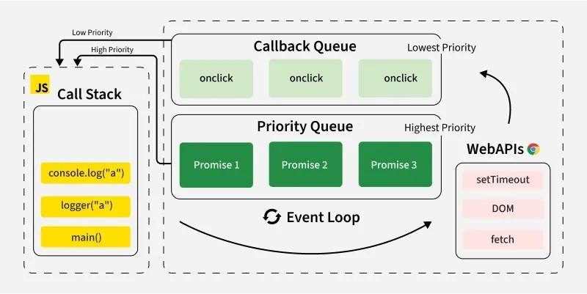

 Async/Await
Definition:
Async/Await is built on Promises and makes asynchronous code look synchronous.

Example:
async function processData() {
try {
const data = await fetch("url");
console.log(data);
} catch(error) {
console.log(error);
}
}

Advantages:
• Easy to read
• Better debugging
• Clean flow control

 Conclusion:
Async/Await improves readability and simplifies asynchronous code handling.

Rules:-
• async function always returns a Promise
• await can be used only inside async function

Error handling in Async – Await:-
Using try–catch block:
async function getData() {
try {
let response = await fetch("url");
let data = await response.json();
console.log(data);
} catch(error) {
console.log("Error:", error);
}
}
Conclusion:
try–catch provides clean and centralized error handling in asynchronous operations.

Fetch API –
Definition:
Fetch API is used to make HTTP requests to servers.
Example using .then():
fetch("https://jsonplaceholder.typicode.com/posts")
.then(response => response.json())
.then(data => console.log(data))
.catch(error => console.log(error));
Example using async/await:
async function getPosts() {
try {
let response = await fetch("https://jsonplaceholder.typicode.com/posts");
let data = await response.json();
console.log(data);
} catch(error) {
console.log(error);
}
}

Conclusion:-
Fetch API combined with Promises or Async/Await is widely used in modern web applications to handle API requests efficiently.

OOP’S :-

Object-Oriented Programming (OOP) is a programming paradigm that organizes software around objects instead of functions.
An object contains:
• Properties (Data)
• Methods (Behavior)

 Why Needed?
• To model real-world entities
• To break large programs into manageable parts
• To improve reusability and maintainability
• To support modular design

 Key Features:
• Combines data and methods in one unit
• Supports reusability
• Improves scalability
• Enhances security through encapsulation

 Example in JavaScript:
class Person {
constructor(name, age) {
this.name = name;
this.age = age;
}
greet() {
console.log("Hello, my name is " + this.name);
}
}
let p1 = new Person("John", 25);
p1.greet();
Output:
Hello, my name is John

 Conclusion:
OOP helps in building scalable, reusable, and real-world modeled applications using objects.

Principles of OOP
There are four main principles:

Encapsulation

- Definition:
Bundling data and methods together and restricting direct access to data.

Example:
class BankAccount {
#balance = 0;
deposit(amount) {
this.#balance += amount;
}
getBalance() {
return this.#balance;
}
}

Inheritance
 Definition:
One class acquires properties and methods of another class.
class Animal {
speak() {
console.log("Animal makes sound");
}
}
class Dog extends Animal {
bark() {
console.log("Dog barks");
}
}

Polymorphism

 Definition:
Same method behaves differently.

Abstraction

 Definition:
Hides implementation details and shows only essential features.

 Conclusion:
OOP principles improve security, flexibility, and reusability in applications.

Node . JS
- Definition:
Node.js is a JavaScript runtime environment that allows JavaScript to run on the server. instead of only inside a browser.

 Earlier:
- JavaScript worked only in browsers (Chrome, Firefox)
- It was used mainly for buttons, forms, and small interactions

 With Node.js:
- Java script can be used to build servers
- It can connect to databases
- It can handle backend logic
So, Node.js makes JavaScript a backend language

Purpose:-
- To create servers
- To handle client requests
- To process business logic
- To connect with databases
- To build APIs

Features of Node.js:-
- Asynchronous (Non-blocking)
Node.js can handle multiple users at the same time
One user does not block another
- Fast Performance
Built on Google Chrome’s V8 Engine
Executes JavaScript very quickly
- Single Language Advantage
JavaScript for frontend + backend

 Example:
const http = require("http");
http.createServer((req, res) => {
res.write("Hello from Node");
res.end();
}).listen(3000);

React.js
- Definition:
React is a JavaScript library used to build user interfaces.
React is mainly used for Single Page Applications (SPA)
- User Interface means:
What users see
What users click
What users interact with

Why Was React.js Created?
Pages load once
Only required parts update
Faster, smoother experience
Purpose of React.js
To create:
Fast websites
Interactive user interfaces
Modern web applications
 Features:
• Component-based
• Virtual DOM
• One-way data binding
• Reusable components
 Example:

function App() {
return <h1>Hello React</h1>;
}

 Conclusion:
Node.js is used for backend development, whereas React is used for frontend UI development.

Difference btw Node and React
Features | Node.js | React.js
What it is | A runtime environment | A JavaScript library
Main Purpose | Used to build backend/server-side applications | Used to build frontend/user interfaces
Where it runs | Runs on the server (computer or cloud) | Runs in the browser
Focus | Handles logic, data, APIs, servers | Handles UI, pages, user interaction
Type of Work | Behind-the-scenes processing | What users see and interact with
Used By | Backend developers | Frontend developers
Handles Database? | Yes | No
Handles UI? | No | Yes
Language Used | Java Script | Java Script (with JSX)
Speed Benefit | Fast due to non-blocking operations | Fast due to Virtual DOM
Learning Role | Teaches server-side concepts | Teaches UI & component concepts

Installation :-
React is a JavaScript library used for building user interfaces. Before using React, it must be installed and a project structure must be created.

Installation Steps
- Install Node.js (includes npm).
- Open Command Prompt / Terminal.
- Run the following commands:
npx create-react-app myapp
cd myapp
npm start
• create-react-app creates a new React project.
• npm start runs the development server.
• The app opens in browser at localhost:3000.

FILE STRUCTURE
myapp/
│
├── node_modules/
├── public/
| └── index.html
├── src/
| ├── App.js
| ├── index.js
| └── components/
├── package.json

Node_modules/
Contains all installed libraries
Auto-generated by npm/yarn
Never edit manually

Public Folder
Contains static files
Important file:
index.html – Main HTML file
React renders the app inside:

React Project Structure (Important files)
src/ → Main app code
├── App.jsx → Main component
public/ → Static files
package.json → Project dependencies

package.json (Very Important)
This is the brain of your project:
Project name & version
Dependencies (react, axios, etc.)

Conclusion

React project structure organizes files properly, separating UI logic, dependencies, and configuration, making development easy and scalable
All eyes on “JSX”

JSX:-
JSX (JavaScript XML)
Its a syntax extension of JavaScript that allows writing HTML-like code inside JavaScript.
It is not actual HTML; instead, JSX gets compiled (transpiled) into normal JavaScript (React.createElement) before being executed by the browser.
Explanation
JSX makes React code more readable and easier to understand.
Browsers do not understand JSX directly. It is converted into JavaScript using Babel compiler.
JSX internally converts into:
React.createElement()

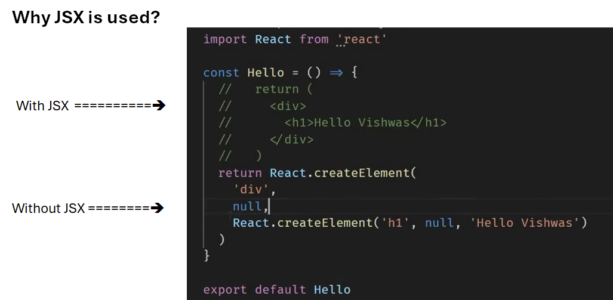

Example

Java script

const element = <h1>Hello, World!</h1>;
Converted into:-
Jsx

Feature | JSX | HTML
Definition | JavaScript XML — JS ke andar HTML-like syntax | Standard markup language for web pages
Usage | React components ke render method ya return statement mein | Normal web pages, browsers directly interpret karte hain
Syntax Rules | - Must have one parent element - class → className - for → htmlFor - Must close all tags (e.g., <img />) - Can embed JS expressions inside {} | - Browser tolerant, multiple roots allowed - Uses class and for normally - Self-closing tags optional in HTML5
JS Expressions | {} curly braces use karke JS expressions embed kar sakte ho | Not possible, HTML is static
Security | React automatically escapes strings to prevent XSS | HTML directly renders, so vulnerable to XSS if not sanitized
Compilation | JSX is transpiled to React.createElement() by Babel before rendering | HTML runs directly in browser

React.createElement("h1", null, "Hello, World!");
THE JSX MUST HAVE SINGLE PAREMT ELEMENT

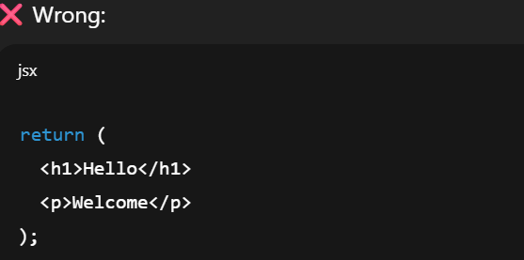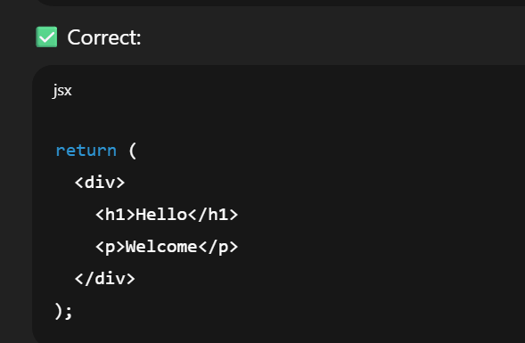

2. Use className instead of class
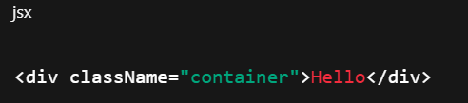

3. JavaScript inside JSX using { }
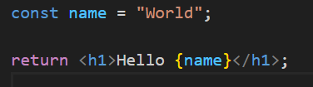

Example {jsx}:-
function App() {
const name = "sita";

return (
<div>
<h1>My App</h1>
<p>Welcome, {name}!</p>
</div>
);
}

export default App;

Advantage:-
- Easy to understand
- Faster development
- Improves readeablity
- Prevents injection attacks
- Supports java scripts expressions

Features of JSX
• Looks like HTML
• Allows JavaScript expressions using {}
• Prevents injection attacks
• Improves readability• Faster development

Conclusion
JSX simplifies UI creation in React by combining HTML structure and JavaScript logic in one place.
In short jsx = HTML like syntax used in react to create UI components easily inside java script
VIRTUAL - DOM
Virtual DOM is a lightweight copy of the real DOM stored in memory.
React does not directly update the browser DOM every time data changes.
Instead:
React updates the Virtual DOM → compares it with previous Virtual DOM → updates only the changed parts in Real DOM.

Why Virtual DOM?
Direct DOM manipulation is slow.
If you change 100 elements → 100 DOM updates = slow performance.
React Style:-
- Change state
- React updates Virtual DOM
- Finds difference (Diffing)

Advantages

✔Faster
✔Improves performance
✔Efficient updates
✔Reduces direct DOM manipulation
✔Better user experience
✔ Better performance for large apps
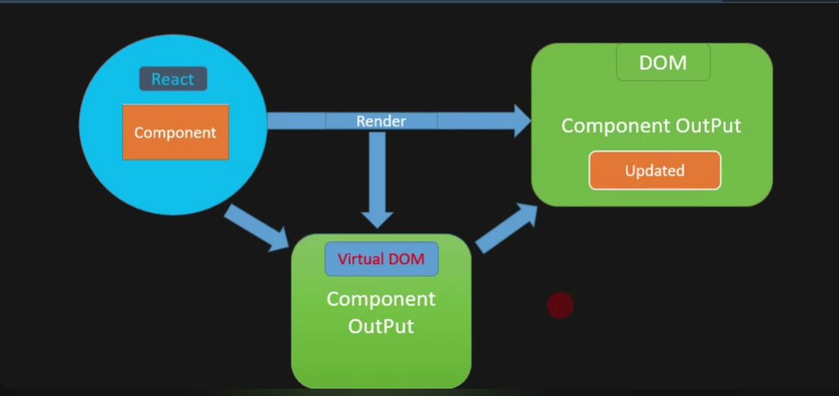

Conclusion
Virtual DOM is a key feature of React that ensures fast and efficient UI updates.
React Components :-
- In React, a component is a reusable, independent unit of the user interface.
- This allow developers to split the UI into small, manageable pieces, making applications easier to develop and maintain
- A React component can be compared to a JavaScript function that accepts input called props and returns JSX (HTML-like syntax).

Feature of Components :-
- Reusable and modular
- Can be nested inside other components
- Can manage data using state and props
- Improve readability and maintainability

Importance
- Components break UI into smaller parts, making applications easier to manage and maintain.

Conclusion
- React components are the building blocks of any React application and improve code reusability and scalability.

Types:-
Functional Components – Written as JavaScript functions
Class Components – Written using ES6 classes

Functional Components:-
- A functional component is a JavaScript function that returns JSX.
- Originally, functional components were used only for UI, but after the introduction of Hooks,
- It also manage state and lifecycle behavior.
- Syntax
function Welcome() {
return(
<div>
<h1>Hello </h1>;
</div>
}

Class Components :-
A class component is written using an ES6 class that extends React.Component.
It can manage state and use lifecycle methods.
Syntax:
class Welcome extends React.Component {
render() {
return(
<div>
<h1>hello</h1>
</div>
)
}

Functional vs class :-

Feature | Functional Component | Class Component
Declaration | Function / Arrow function | ES6 Class extends React.Component
Syntax | Simple, returns JSX directly | Requires render() method to return JSX
this Keyword | Not required | Required to access props and state (this.props, this.state)
State Management | useState (Hook) | this.state object + this.setState()
Life-cycle Methods | useEffect Hook replaces all lifecycle methods | componentDidMount, componentDidUpdate, componentWillUnmount, etc.
Performance | Slightly better, lighter, optimized | Slightly heavier due to class overhead
Code Reuse | Custom Hooks for reuse | HOCs (Higher-Order Components) or Render Props
Error Boundaries | Cannot be used directly (need wrapper class) | Can implement componentDidCatch for error boundaries
Example | jsx function Greeting(props) { return <h1>Hello {props.name}</h1>; } | jsx class Greeting extends React.Component { render() { return <h1>Hello {this.props.name}</h1>; } }

Conclusion
- Functional components are preferred in modern React due to simplicity and Hooks support.

PROPS:-
- Props are used to pass data from one component to another, usually from parent → child.
- Props are read-only
- Child components cannot modify props
- Used for component communication

Why to use props:-
- Reusability of components
- Dynamic data rendering
- Clean separation of logic and UI

Example :-

Parent:- | Child:
function App() {  return <Welcome name="Dr. Diana" />;  } | function Welcome(props) {  return <h1>Hello, {props.name}</h1>;  }

❤Conclusion
Props allow communication between components and make UI dynamic and flexible.

HOOK:-
Hooks are special functions introduced in React 16.8 that allow you to use state and other React features in functional components, without writing class components.
Why Hooks?
Make code simpler and cleaner
Avoid complex class syntax (this, constructor, binding)
Reuse stateful logic easily
Improve readability and maintainability

Using Hooks:-
- function starting with use key-word are called Hooks
- useState is a built-in hook provided by React
- we can find other built-in hook in API -reference
- they are restricted than other function
Commonly Used Hooks
- useState() – State management
- useEffect() – Side effects (API calls, subscriptions)

STATE:-
- State is a built-in object that stores component-specific data that can change over time.
- When state changes → React re-renders the component
- State is mutable (can be updated using setter functions)

use State-Hook:-
- useState is a React Hook used to manage state in functional components.

Syntax
const [state, setState] = useState(initialValue);

Example

import { useState } from "react";
function Counter() {
const [count, setCount] = useState(0);
return (
<>
<p>{count}</p>
<button onClick={() => setCount(count + 1)}>
Increase
</button>
</>
);
}

Explanation
• count stores state value
• setCount() updates state
• When state updates, component re-renders automatically

Features
• Simple state management
• Automatic UI update
• Cleaner than class state
• Used in modern React

Conclusion
useState Hook simplifies state handling in functional components and is widely used in modern React development

UseEffect :-
- useEffect() is a React Hook used to perform side effects in functional components.
- Side effects include:
- Fetching data from an API
- Updating the DOM

Syntax:-
useEffect(() => {
// side-effect code
}, [dependencies]);

===============================================================================================

React Component Lifecycle :-
React Component Lifecycle refers to the series of stages a component goes through from creation to removal from the DOM.
In class components, lifecycle is controlled using lifecycle methods.
In functional components, lifecycle behavior is handled using Hooks like useEffect.

Main Phases of React Lifecycle
React lifecycle has three main phases:
- Mounting Phase
- Updating Phase
- Unmounting Phase

Mounting Phase
This phase occurs when a component is created and inserted into the DOM.
Methods in Class Component:
• constructor()
• render()
• componentDidMount()

Updating Phase
This phase occurs when props or state changes.
Methods:
• shouldComponentUpdate()
• render()
• componentDidUpdate()

Unmounting Phase
This phase occurs when a component is removed from the DOM.
Method:
• componentWillUnmount()

Conclusion
React lifecycle helps developers control component behavior at different stages, improving performance and resource management.

Mounting Phase
Mounting is the phase where a component is created and inserted into the DOM for the first time.

Steps in Mounting
- constructor() – Initializes state
- render() – Returns JSX
- componentDidMount() – Executes after component is added to DOM

Example (Class Component)
class Example extends React.Component {
constructor(props) {
super(props);
this.state = { message: "Hello" };
}
componentDidMount() {
console.log("Component Mounted");
}
render() {
return <h1>{this.state.message}</h1>;
}
}

Explanation
• constructor initializes state
• render displays UI
• componentDidMount runs after rendering

Conclusion
Mounting phase is used to initialize data and perform tasks like API calls after component loads.

Updating & Unmounting Phases

Updating Phase
This phase occurs when state or props change.
Important Methods:
• shouldComponentUpdate() – Decides whether re-render is needed
• render() – Updates UI
• componentDidUpdate() – Executes after update
Example:
componentDidUpdate() {
console.log("Component Updated");
}

Unmounting Phase
This phase occurs when a component is removed from the DOM.
Method:
• componentWillUnmount()
Used for:
• Clearing timers
• Cancelling API requests
• Removing event listeners
Example:
componentWillUnmount() {
console.log("Component Unmounted");
}

Conclusion
Updating handles re-rendering, while unmounting handles cleanup operations.

Comparison of Life cycle Phases

Feature | Mounting Phase | Updating Phase | Unmounting Phase
Meaning | Component is created and inserted into DOM | Component re-renders when state or props change | Component is removed from DOM
When It Occurs | When component loads for first time | Whenever state/props update | When component is destroyed
Frequency | Happens only once | Can happen multiple times | Happens only once
Purpose | Initialize component and load data | Update UI when data changes | Cleanup resources
Main Methods (Class) | constructor(), render(), componentDidMount() | shouldComponentUpdate(), render(), componentDidUpdate() | componentWillUnmount()
Hook Equivalent (Functional) | useEffect(() => { ... }, []) | useEffect(() => { ... }, [dependency]) | useEffect(() => { return () => { ...cleanup... } }, [])
Common Usage | API calls, initialize state | Re-render UI on change | Clear timers, remove event listeners

Mounting → Initialize
Updating → Re-render
Unmounting → Cleanup

UseEffect -Hook IN Life-cycle:-
- useEffect is a React Hook used in functional components to handle lifecycle events such as mounting, updating, and unmounting.

Purpose of useEffect
• Perform side effects
• API calls
• Timer setup
• Event listeners
• DOM updates

Syntax
useEffect(() => {
// side effect code
}, [dependency]);

Example
import { useEffect } from "react";
function Example() {
useEffect(() => {
console.log("Component Mounted");
}, []);
return <h1>Hello</h1>;
}

Explanation

Empty dependency array [] → Runs once (Mounting)
With dependency → Runs on update

Conclusion
useEffect replaces lifecycle methods in functional components and manages side effects efficiently.

Cleanup Function in useEffect
- Cleanup function is used to remove side effects when component unmounts or before re-running effect.

Why ?
• Prevent memory leaks
• Stop timers
• Remove event listeners

Example
useEffect(() => {
const timer = setInterval(() => {
console.log("Running...");
}, 1000);
return () => {
clearInterval(timer);
console.log("Cleanup Done");
};
}, []);

Explanation
• Code inside return() acts as cleanup
• Executes when component unmounts

Conclusion
Cleanup functions ensure efficient memory management in React applications.

Event Handling in <React>
- Event handling in React allows developers to respond to user actions such as clicks, typing, and form submissions.

Features
• Uses camelCase (onClick)
• Pass function reference
• Uses Synthetic Events

Example
function Button() {
function handleClick() {
alert("Button Clicked");
}
return <button onClick={handleClick}>Click Me</button>;
}

Explanation
• onClick is React event
• handleClick function executes on click

Conclusion
React event handling makes UI interactive and dynamic.

User Interaction:-
User Interaction refers to the actions performed by a user on a website or application, and how the system responds to those actions.

Example
import { useState } from "react";
function Counter() {
const [count, setCount] = useState(0);
return (
<>
<p>Count: {count}</p>
<button onClick={() => setCount(count + 1)}>
Increase
</button>
</>
);
}

Explanation
• User clicks button
• State updates
• Component re-renders

Conclusion
React efficiently handles user interaction through state and event handling.
User interaction is the communication between user and application through events, where user actions trigger system responses
__________________________________________________________________________________________________________________

useReducer in react:-

- The useReducer hook is a powerful alternative to use State for managing complex state logic in React.
- It's especially useful when state transitions depend on previous values or involve multiple sub-values.

- Its a react hook used for managing complex state logic
- you should use useReducer instead of use State

- when state logic is complex
- If your state has multiple values or many updates, useReducer is better
example:-
from with many fields
shopping cart [add/remove/update items]
game logic
dashboard state management

Syntax:
Const[state, dispatch] =
useReducer(reducer, initialstate);
const [state, dispatch] = useReducer(reducer, initialState);

State
State represents the current state of the component

initial state
Initial state is starting value if state
const initialState = {count: 0}

Then
state={count: 0}
After an action like increment:
state={count: 1}
so state always stores the latest value

Dispatch
Dispatch is a function used to send actions to the reducer

Reducer
Reducer is a function that control how state changes

Custom Hook:-
- A custom Hook is a java script function that allows developers to reuse logic in multiple react component
- It use built-in React hook such as useState, useEffect, useContext, etc
- Its name must start with use
- Custom hook help in extracting component logic making code re-usability and cleaner.

Uses of Custom Hook:
- Custom hooks used for:
- Reusing logic across multiple components
- reducing code duplication
- Separate logic from UI
- making component easier and cleaner to maintain
Advantage:
- improves code re usability
- make code modular
- enhances readability
- simplifies component structure

Rules:-

- Hook name must start with ‘use’
Example:-
UseCounter, useFetch, useAuth
- Hook must be called only inside React component or other hook
- Hook cannot be used inside normal java script functions
- They must be used inside
  - Functional component
  - Custom hook
- Hook must be call at the top level
- Hooks should not be used inside loops conditions or nested function
- Custom hook can internally use built-in hooks
such as:
- useState
- useEffect
- useContext
- useReducer

Extracting Component Logic:-
- Extracting Component logic means moving reusable logic from component into a custom hook
- Sometimes as a component contains a large amount of logic such as:-
state management
API calls
Event handling
data processing
- when this logic is placed directly inside the component, the component becomes difficult to read and maintain

Reusable Hooks
- Reusable hooks are custom hook that can be used in multiple component to share the same logic
- instead of writing the same code repeatedly in different component, developers create a single custom hook and reuse it whenever needed
- Advantage:
  - reduces code duplication
  - Improves code organization
  - Makes application easier to maintain
  - promotes modular programming

